New Member Sign Up

**Autoship**

|  |
| --- |
|  |

Yes,

|  |  |
| --- | --- |
| I want to enroll as an Associate and participate in the Autoship Program for an annual fee of $28, which will provide valuable benefits such as…   * Reward Pricing. Get the absolute lowest price on all products including the special paks * Maintain active status and capture all group order volume within your organization * Stay qualified to participate in the compensation program * Participate in special and exclusive promotions   Get scheduled delivery of your favorite products, paks |  |
| No thanks, please show me other options. |  |

If choose Yes, then go this page

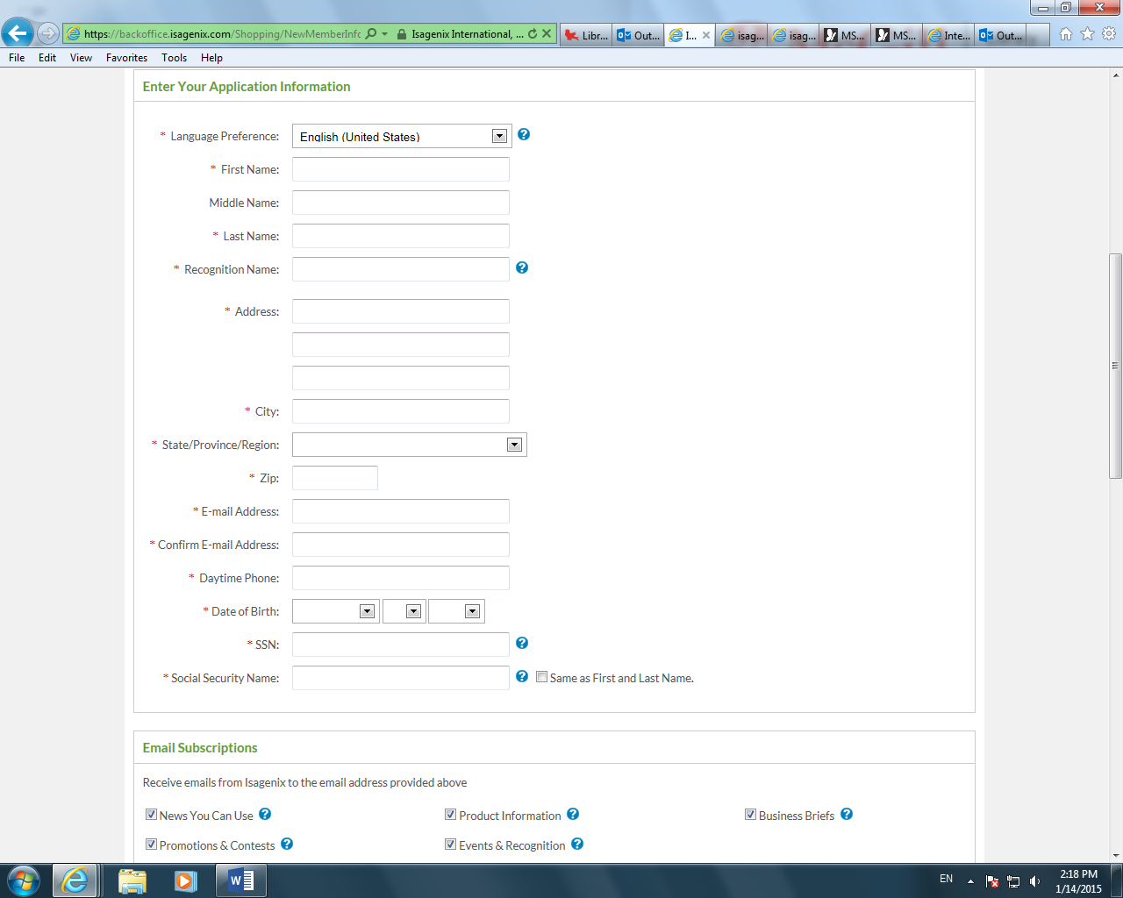

We do not need Language Preference, do not need Middle name, Recongnition name. Social security number does not have to be red. Also donot need Email Subscriptions.

Add:

1. Company Information, if sign up as a company

Company Name:

Type of Company

1. Referred By:

( ) I agree to the policies and procedures.

(To view the policies and procedures…..Click here)

Submit

If choose No on the first page

Then there are the following options

###### Select An Account



Associate Account (with Autoship) $28 Annual Membership Cost - If you like to have the lowest possible product pricing and have the possibility to make a substantial income in the process then this is the best choice for you! Get scheduled delivery of your favorite products, paks at our lowest prices, which reflect special rewards pricing on select items. Also, enjoy the benefits of our generous Compensation Plan and exclusive special promotions.





Preferred Customer Account (with Autoship) $28 Annual Membership Cost - If you’re not interested in the income opportunity but still want scheduled delivery of your favorite products at wholesale prices, then this is a good choice for you! Should you decide that you don’t want to pass up the chance to earn some extra cash, then upgrade to Associate Status at no additional cost anytime within your first two years.



Preferred Customer Account (without Autoship) $38 Annual Membership Cost If you’re not interested in the income opportunity but want to enjoy wholesale prices on products when you place your order each month, then this is the choice for you! Should you decide that you don’t want to pass up the chance to earn some extra cash, then upgrade to Associate Status at no additional cost anytime within your first two years.